Cancer Statistics in the United States
- More than 15.5 million Americans with a history of cancer were alive on January 1, 2016
- Approximately 1,688,780 new cancer cases are expected to be diagnosed in 2017
- Approximately 600,920 Americans are expected to die of cancer in 2017, which translates to about 1,650 people per day
- Cancer is the second most common cause of death in the US, exceeded only by heart disease (accounts for nearly 1 of every 4 deaths).
(American Cancer Society, 2017)

Cancer Biology and Pathophysiology
Carcinogenesis—transformation into a cancer cell
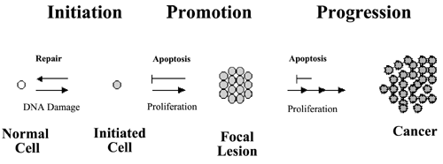
Key Cancer Cell Concepts:
-Will continue to differentiate (transform) and proliferate (grow)
-Lack inhibitory processes normally in place to prevent continual growth)
-Become immortal &
plemorphic (varying in size and shape)
-Cancer cells have an altered metabolism (basis of the PET scan)

A cancer cell is present. What causes disease?
- Continued growth alter physiology of tissue
- Metastasis—travels from tissue of origin to other organs, altering their physiology (common sites of metastasis: lung and liver)
- Can occur by:
  - Moving adjacently
  - Angiogenesis (creation of blood supply, traveling through vascular system)
  - Lymphatic (lymph nodes to circulatory system)

Cancer and Immunity
- Cellular differentiation causes the immune system to notice a cell that is not normal (random protein outside of cell, immune system flags it as foreign)
- Decreased immunity=Increased cancer risk
- The fundamental concept behind immunotherapy or biotherapy (identify a protein common to a tumor typecreate an antibody to target give to patient and allow immune system to destroy cancer cells)

Risk Factors
INTERNAL | EXTERNAL
- Cannot be modified  - Occur in the body despite external factors  - e.g., familial cancer syndromes, identified oncogenes (BRCA₁, BRCA₂) | - Long-term inflammation= increased risk for cancer (stimulates cellular proliferation)  - Smoking— chemicals (carcinogens) + long-term inflammation = cancer  - Other carcinogens (radiation, asbestos, alcohol, chemotherapy)
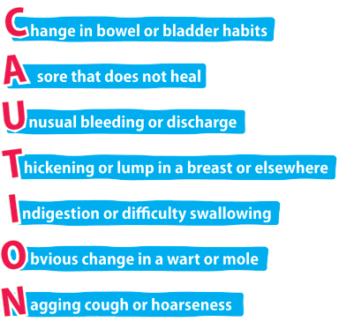
Diagnosis
- Health History and Physical Examination
- Laboratory and Diagnostic Studies
- Biopsy (DEFINITIVE DIAGNOSIS)
- Microscopic Examination (determine Grade. Grade I-IV higher grade=higher threat to mortality)

Cancer Staging
- Different types of cancer staging systems.
- Tend to have the following components
  - Primary tumor site and cell type (e.g., squamous cell carcinoma, adenocarcinoma)
  - Tumor size and/or extent
  - Regional Lymph Node involvement
  - Number of tumors/Presence of metastasis
  - Tumor Grade (degree of cellular differentiation—alteration of morphology)
Treatment
Surgery
- Goal: biopsy, prevention (BRCA1 positive), resection of tumor, palliation (relieve obstruction), and reconstruction.
- Negative Tumor Margin
- General Surgical Interventions
  - NPO
  - Strict I/O
  - Bowel regimen
  - Pain management
  - Monitor incision site and drains
  - Urinary catheter 48hr post-op
  - Thromboembolism prevention (heparin/lovenox, SCDs)Cancer patients are hypercoagulable
  - EARLY MOBILIZATION
Chemotherapy, Biologic and Targeted Therapies
- Goal: cure disease, control progression, palliative treatment
- May be administered PO, IV, Injection, intrathecal, intracavity
- May be administered inpatient, office, infusion clinics, at home
- Cytotoxiccauses gene alteration triggering apoptosis
- Nursing Considerations—Administration
  - Ensure Blood return in central venous lines and ports
  - Ensure patency of IV
  - Educate on side effects
  - Chemo-precautions
  - Special personal protective equipment
- There are many side effects (including newly identified ones): NCLEX will most likely focus on
  - Pancytopenia (↓Blood counts)
  - GI symtpoms (N/V/D, mucositis)
  - Alopecia
Radiation Therapy
- Goal: destroy or inactivate malignant cells while minimizing damage to normal tissue within the treatment volume
- May be given with other treatments, prophylactically, control, palliation
- Include External beam (teletherapy) and radioactive source therapy (brachytherapy)
Safety
- Radiopharmaceuticals—flush three times, special PPEs
- Sealed sources (brachytherapy)—shielded containers in room, long forceps to place source into lead container, dressings changed by physician, do not share dosimeters
Side Effects
- For side effects related to radiation, remember INFLAMMATION/FIBROSIS (should be near radiation fieldExample: skin irritation above radiation site, dysphagia if near throat, etc.)
Complications
Neutropenic FeverSepsisSeptic Shock: Popular test item (Patient is s/p chemotherapy and presents with a temperature of 38.1ºC (100.5ºF), what should you do? Freak out! Red Flag! SOS!)
Tumor Lysis Syndrome (TLS)
- Lysis of tumor cells release of intracellular componentsbody unable to metabolize leading to :

  - Hyperkalemia
  - Hyperuricemia
  - Hyperphosphatemia
  - Hypocalcemia

TLS management (Bear in mind for NCLEX questioning, it is safety. They just want to know that you can identify that a patient is in trouble. You will not necessarily be tested on management)
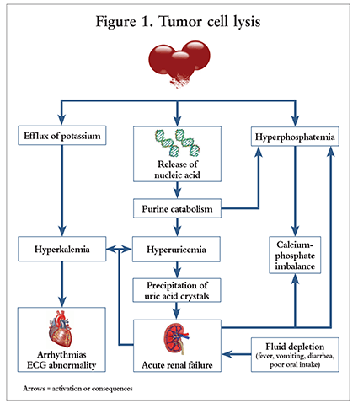
- ICU admission (continuous telemetry monitoring WHY?)
- Laboratory Studies every 6 hours (Basic Metabolic Panel, Phosphorus, Lactate Dehydrogenase, Calcium, uric acid)
- Hydration, hydration, hydration! (unless kidneys have already failed) (Normal Saline at 300mL/hr)
- Diet modification
- Pharmacological interventions to manage electrolytes (insulin, dextrose, calcium gluconate, rasburicase)
- If kidney function begins to fail and pharmacological interventions fail, then dialysis
Spinal Cord Compression
- Occurs as a result of tumor invasion to vertebrae, resulting in a subsequent collapse of spinal cord
- Delay in care can threaten patient’s ambulatory status (treatment required within 24 hours of neurological compromise)
- First line intervention—high dose corticosteroids (decreases spinal cord edema)

Malignant Dermatological Disorders
- As you can see squamous cell carcinomas are not as deep as the other two (these carcinomas tend to have an ulceration).
- Basal cell carcinomas tend to look more like a papule (rounded and rised)
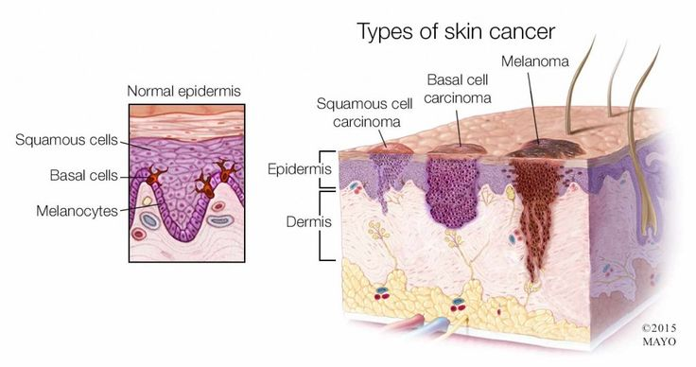
- Then melanoma is very straight forward. A mole with suspicious components (ABCDE) Asymmetry, Border, Color, Diameter (larger than 1/4in), and Evolving (changes from original molebecomes more faded).
Psychosocial
Psychosocial issues that arise in the oncological patient:
- Culture, spirituality, religion
- Altered body image
- Ineffective coping
- Anxiety
- Depression
- Loss of personal control
- Loss and grief
- Sexuality
Assessment
- Advocacy and inquiry: Observation + Open-ended question
- Sometimes all a patient needs is someone to listen. He or she has lost control and attempting to cope. It is tempting to say something. Don’t. Shhh. (now the NCLEX will want you to say something, these answers tend to be questions or very general statements. Never advise and focus on safetysuicidal ideation.)
- Refer to appropriate services: there are many services out there to assist oncology patients.

